**INDUCTIVE REACTANCE**

**LAB # 03**



**Fall 2022**

**CSE-203L**

**Circuits & System-2 Lab**

Submitted by: **NAVEED AHMAD**

Registration No.: **22PWCSE2165**

Class Section: **B**

“On my honor, as student of University of Engineering and Technology, I have neither given nor received unauthorized assistance on this academic work.”

Student Signature: ______________

Submitted to:

**Engr. Usman Malik**

Nov.2023

Department of Computer Systems Engineering

University of Engineering and Technology, Peshawar

**Inductive reactance**

**Objective:**

Investigate the relationship between inductive reactance, inductance, and frequency, and create a plot of inductive reactance versus frequency. Understand inductive reactance as the opposition to changes in current flow, causing a phase shift in alternating current concerning alternating voltage in an ideal inductor.

**Theory Overview:**

In an AC circuit, an inductor's current-voltage characteristic differs from that of resistors. Unlike resistors with constant resistance, inductive reactance, the ohmic value for an inductor, is directly proportional to frequency. The formula to compute inductive reactance is XL = 2πfL. Experimentally, determine the magnitude of inductive reactance by applying a known current to an inductor, measuring the resulting voltage, and calculating reactance using Ohm’s Law. Repeat this process across various frequencies for an in-depth inductive reactance versus frequency plot.

**Equipment:**

1. AC function generator
2. Oscilloscope
3. Inductors of different values
4. Resistor: 10kΩ

**Procedure:**

Utilize an AC circuit with a series resistance to approximate an AC current source. Ensure the resistance is significantly larger than the expected maximum reactance.

Employ different inductors with known values. Measure and record the circulating current for each inductor at various frequencies in Table 1.

Construct circuits using inductors of varying values. Measure the resulting voltage and calculate the theoretical inductive reactance (XL) using the formula XL = 2πfL. Record these values in Table 2.

Repeat the process for different frequencies and inductors, recording experimental inductive reactance and deviations.

Plot inductive reactance versus frequency using data from Tables 1 and 2.

**Equipment and experiment:**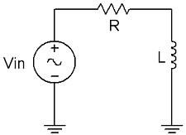

1. AC Function Generator
2. Oscilloscope DMM
3. 1 mH actual:
4. 10 mH actual:
5. 10 kΩ actual:

**Circuit and figures:**

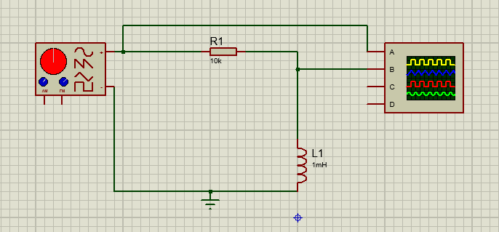

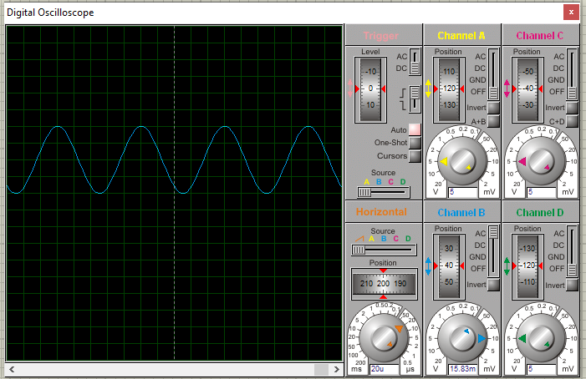

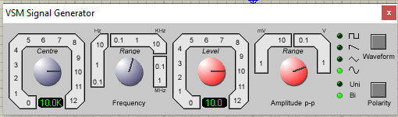

* **Current Source**

Using Figure 1 with Vin=10 Vp-p and R=10 kΩ, and assuming that the reactance of the inductor is much smaller than 10k and can be ignored, determine the circulating current using measured component values and record in Table 1.

* **Measuring Reactance**

Build the circuit of Figure 1 using R=10 kΩ, and L=10 mH. Place one probe across the generator and another across the inductor. Set the generator to a 1000 Hz sine wave and 10Vp-p. Make sure that the Bandwidth Limit of the oscilloscope is engaged for both channels. This will reduce the signal noise and make for more accurate readings.

* Calculate the theoretical value of XL using the measured inductor value and record in Table2.
* Record the peak-to-peak inductor voltage and record in Table 2.
* Using the source current from Table 1 and the measured inductor voltage, determine the experimental reactance and record it in Table 2. Also compute and record the deviation.
* Repeat steps three through five for the remaining frequencies of Table 2.
* Replace the 10 mH inductor with the 1mH unit and repeat steps two through six, recording results in Table 3.
* Using the data of Tables 2 and 3, create plots of inductive reactance versus frequency.

**Table**

|  |  |  |  |  |
| --- | --- | --- | --- | --- |
| Frequency  (kHz) | XL Theory  (ohm) | VL(p-p) Exp  (mV) | XL Exp  (ohm) | % Dev |
| 1 | 6.28 | 6.64 | 6.64 | 5.7 |
| 2 | 12.56 | 13.08 | 13.08 | 3.97 |
| 3 | 18.84 | 18.96 | 18.96 | 0.6332 |
| 4 | 25.12 | 24.66 | 24.66 | 1.865 |
| 5 | 31.40 | 31.84 | 31.84 | 1.38 |
| 6 | 37.68 | 39.00 | 39.00 | 3.38 |
| 8 | 50.24 | 51.32 | 51.32 | 2.104 |
| 10 | 62.80 | 63.00 | 63.00 | 0.317 |
| 20 | 125.6 | 0.13 v | 130 | 3.38 |
| 30 | 188.4 | 0.196 v | 196 | 3.8 |
| 40 | 251.2 | 0.26 v | 260 | 3.38 |
| 50 | 314 | 0.32 v | 320 | 1.875 |
| 60 | 376.8 | 0.39 v | 390 | 3.38 |
| 80 | 502.4 | 0.51 v | 510 | 1.49 |
| 100 | 628 | 0.65 v | 650 | 3.38 |

**conclusion:**

Inductive reactance is the name given to the opposition to a changing current flow. This impedance is measured in ohms, just like resistance. In inductors, voltage leads current by 90 degrees. In case of pure resistive circuit, the phase angle between voltage and current is zero and in case of pure inductive circuit, phase angle is 90o but when we combine both resistance and inductor, the phase angle of a series RL circuit is between 0o to 90o.